Business Report

SMDM Project Business Report DSBA

***Sanjay Srinivasan***

***PGP-DSBA Online***

***JULY’ 21 Batch***

***Date: 15-05-2022***

# *INDEX*

|  |  |  |
| --- | --- | --- |
| ***S. No*** | ***Contents*** | ***Page* No** |
| **1.** | **Problem - 1** | 4 |
|  | Summary | 4 |
|  | Introduction | 4 |
|  | Data Description | 4 |
|  | Sample dataset | 4 |
|  | Exploratory data analysis | 4 |
|  | 1) Draw Stock Price Graph(Stock Price vs Time) for any 2 given stocks with inference | 5 |
|  | 2) Calculate Returns for all stocks with inference | 6 |
|  | 3) Calculate Stock Means and Standard Deviation for all stocks with inference | 6 |
|  | 4) Draw a plot of Stock Means vs Standard Deviation and state your inference | 7 |
|  | 5) Conclusion and Recommendations | 8 |

***List Of Figures***

|  |  |  |
| --- | --- | --- |
| ***S.No*** | ***Content*** | ***Page No*** |
| 1.1 | Dataset Sample Before Changing Column Names | 4 |
| 1.2 | Dataset Sample After Changing Column Names | 4 |
| 1.3 | Sample Datatypes of the variable | 4 |
| 1.4 | Scatter plot for the stock prices of every company. | 5 |
| 1.5 | Sample Return calculation dataframe. | 6 |
| 1.6 | Mean value for every company Stock price | 6 |
| 1.7 | Standard deviation value for every company Stock price | 6 |
| 1.8 | Loading Mean and standard deviation into a dataframe. | 7 |
| 1.9 | Stock means vs. Stock deviation | 7 |
| 1.10 | Sorting Volatility in ascending order. | 7 |
| 1.11 | Taking average values greater than 0. | 8 |

# Problem - 1

*Summary*

The dataset contains 6 years of information (weekly stock information) on the stock prices of 10 different Indian Stocks.. This dataset has stocks for 10 company for 6 years.

*Introduction*

The purpose of this exercise is to find the stock prices of the company with good returns with low risk rate.

*Data Description*

1. Date – 6 year date from 2014- 2021

2.Company – 10 different company stock prices across 6 years.

*Sample of the dataset:*

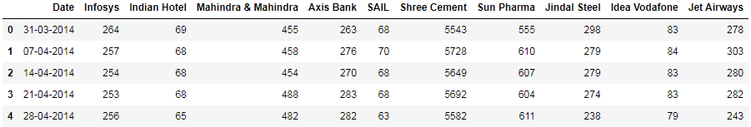

Fig 1.1 Dataset Sample Before Changing Column Names

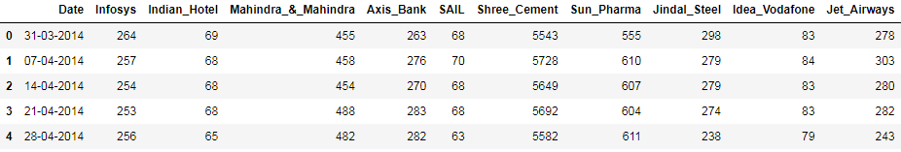

Fig 1.2 Dataset Sample After Changing Column Names

*Exploratory Data Analysis*

*Let us check the types of variables in the data frame.*

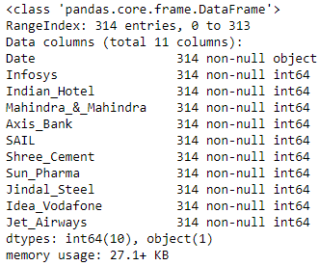

Fig- 1.3. Sample Datatypes of the variable

There are total 314 rows and 10 columns in the dataset.

**2.1 Draw Stock Price Graph (Stock Price vs. Time) for any 2 given stocks with inference**

Plotting of each company's stocks in the scatter plot.

|  |  |
| --- | --- |
|  |  |
|  |  |
|  |  |

Fig- 1.4 Scatter plot for the stock prices of every company.

##### ***Inference from the above stock Graph***

### *Infosys stock:*

The stock price of the increases from 2014-21. Sudden dip in the stock price is due to recession (layoff of the employee) and brokerage houses lowered margin estimates this leads to slow growth.

### *Idea Vodafone stock:*

The stock price of the Idea_Vodafone started falling when Jio has been launched in 2015.The plans where cheaper and good coverage of network leads to fall of the stock price of the Idea_Vodafone shares in the market.

### *Jet Airways stock:*

The fall of jet airways share price, The Company was ceased in 2019 due to financial crunch in the market. This leads to fall of the share price in the market.

**2.2 Calculate Returns for all stocks with inference**

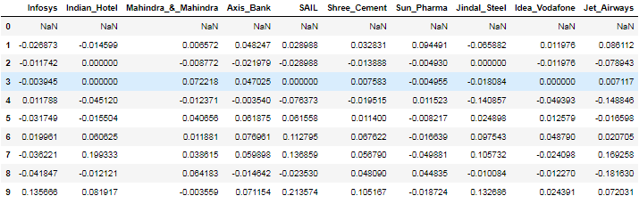

Fig- 1.5 Sample Return calculation dataframe.

***Formula for Stock Return value across time (t):***

$R_{t}$ = $\frac{P_{t} - P_{t-1}}{ P_{t-1}}$

Inference: To return are calculated by the difference of new price from old price by old price. From this we can get the change in stock return can be identified.

### 2.3 Calculate Stock Means and Standard Deviation for all stocks with inference

|  |  |
| --- | --- |
| Fig- 1.6 Mean value for every company Stock price | Fig- 1.7 Standard deviation value for every company Stock price |

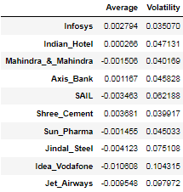

Fig – 1.8 Loading Mean and standard deviation into a dataframe.

***Inference :***

Mean – Gives the average value of stock return..

Standard deviation – Gives the standard deviation value of stock prize.

### 2.4 Draw a plot of Stock Means vs Standard Deviation and state your inference

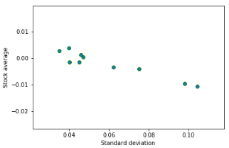

Fig – 1.9 Stock means vs. Stock deviation

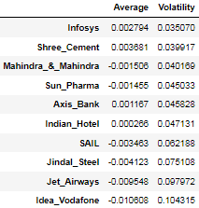

Fig – 1.10 Sorting Volatility in ascending order.

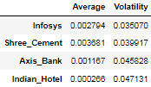

Fig – 1.11 Taking average values greater than 0.

#### Taking the stocks which are having the stock average greater than 0.

#### These 4 stocks are having higher average and lower volatility with high return with lower risk.

#### 4 stocks are having higher returns in the different sector.

#### Ones with higher return for a comparative or lower risk are considered better.

**2.5 Conclusion and Recommendations**

From the above dataframe,

Stock with a lower mean & higher standard deviation does not play a role in a portfolio that has competing stock with more returns & less risk. Thus for the data we have here, we are only left few stocks:

Ones with higher return for a comparative or lower risk are considered better

From this we can infer that Investing in the Infosys can get higher return in the future with low risk and investment needs to be done for long term. Short term investment can lead to lower return or null return.